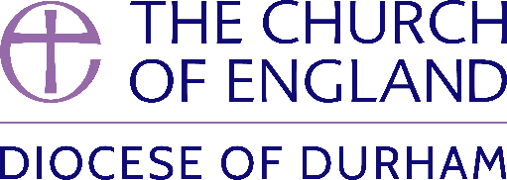
Please complete in black ink

CHURCHWARDEN’S WRITTEN DECLARATION

To be signed by each churchwarden elected to office and returned no later than 31st May 2022

ARCHDEACONRY OF _________________________________

PARISH OF…………………………………………………….………………………………

DECLARATION BY CHURCHWARDEN

Name……………………………………………… Address……………………………………………..
(Mr  Mrs  Miss  Ms )
……………………………………………..

……………………………………………..

.…………………………………………….

I declare that I will faithfully and diligently discharge the duties of the office of churchwarden for the above parish during the period of my appointment, and that I am not disqualified from holding office as a churchwarden under section 2(1), (2) or (3) of the Churchwardens Measure 2001.

Signed…………………………………………….. Date………………………………………………….
This must be a physical signature!

I will / will not be attending the Visitation in the cathedral on 26th June
(Please delete as appropriate)

Notes:
- The disqualifications are (a) disqualification as a charity trustee under s.178 of the Charities Act 2011; (b) inclusion in a barred list (within the meaning of the Safeguarding Vulnerable Groups Act 2006 (c) conviction of an offence mentioned in schedule 1 to the Children and Young Person’s Act 1933(unless waived in writing by the Bishop) (d) disqualification under section 10(6) of the Incumbents (Vacation of Benefices) Measure (1997). If you are in any doubt as to whether you are disqualified, please consult the Diocesan Registrar before signing this form.
- This form, when completed, will be retained by your Archdeacon. It would also be helpful for the Archdeacon and other diocesan officials and office holders to have the following contact details which you are invited to supply:-

Telephone ……………………………………… Mobile Number ………………………………………

E-mail …………………………………………………………………

Notice is given to churchwardens that their names, addresses, telephone, mobile and e-mail address will be held, in electronic format on the Diocesan Office Database and used for direct mailing by authorised Diocesan staff (including Senior Staff and Archdeacons’ Secretaries).
Your contact information could be made available to users of the Diocesan Website if you so wish, however if you DO NOT want your contact information published on the Diocesan website, please put a tick in the relevant box.

Telephone Mobile Email address

