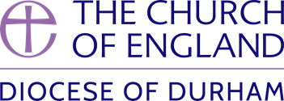
Net Zero Action Plan -Phase 1

Name of Parish
Name of Church
Person(s) completing the action plan

Step 1: PCC to nominate a Net Zero Carbon (NZC) Lead on the PCC and if appropriate form a small NZC Working Group
Step 2: Complete Energy Footprint Tool on the Parish Returns Website and summarise the information below.
 | Building 1 | Building 2 | Building 3
Name e.g. church, hall
Size (sqm)
Heating Type
Carbon emitted
Total Carbon

Step 3: Complete the Practical Path to Net Zero Checklist
PP2NZC_SelfGuidedChecklist_onscreen_version.pdf (churchofengland.org)
Step 4: Review the Church Building Council (CBC) Guidance on Net Zero Carbon
https://www.churchofengland.org/resources/churchcare/net-zero-carbon-church
Step 5: Using the information from the Practical Path to Net Zero Checklist and the CBC Guidance on Net Zero Carbon, complete the table overleaf to begin forming your action plan.
Step 6: Identify what further support / information that you need to obtain to allow you to develop your action plan.

This completed form should be emailed to netzero@durham.anglican.org no later than 30/6/2024.
Quick Wins (zero or minimal cost):
 | Action | Resources required | Who’s responsible?
1
2
3

Medium Term Actions (next 2 years):
 | Action | Resources required | Who’s responsible?
1
2
3

Longer Term Actions (by 2030):
 | Action | Resources required | Who’s responsible?
1
2
3

Further information and support required:

