Who is it run by?
The course will be run by Andy Harris (Leader of Youth Mission and Ministry, Durham Diocese) and other local youth leaders. All leaders will be appropriately vetted (including DBS checking). All activities are subject to sensible risk assessment to minimise the chances of injury or accidents. In all activities there is a ratio of at least 1 adult to every 8 young people.
Programme
Date/s | Time | Location | Theme
Sat 8th Oct  2022 | 10-1pm | Cuthbert House | - Leadership Matters
Fri 11th Nov /  Sat 12th Nov | 6.30pm -3.00pm | Cuthbert House | Residential  - Growing your gifts
Sat 3th Dec | 10-1pm | Cuthbert House | - Leading where you are
Sat 14th Jan 2023 | 10-1pm | Cuthbert House | - Part of the team
Sat 11th Feb | 10-1pm | Cuthbert House | - Making your voice heard
Fri 10th Mar /  Sat 11th Mar | 6.30pm -3.00pm | Cuthbert House | Residential  Projects  - Part of something bigger
Sat 1st April | 10-2pm | Cuthbert House | - Keeping on growing – Final Presentation

NB There may be some dates that you might not be able to make, but we would expect young people to be there for the majority of the course.
Further details
Kate Martin kate.martin@durham.anglican.org Tel: 0191 3746017
Andy Harris andy.harris@durham.anglican.org Tel: 07796769307
Booking is now open. Spaces are limited so early booking is recommended.
Youth Leadership Training
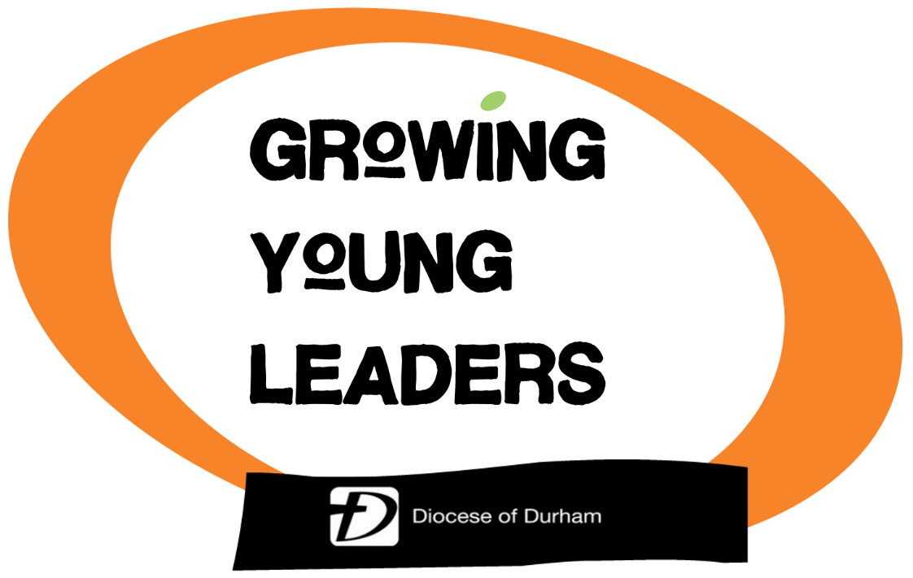
October 2022 – April 2023

Are you in year 10-13 and looking for the opportunity to grow in your leadership skills?

Booking Form
The form below (or copy) should be completed and returned to Kate Martin, Cuthbert House, Stonebridge, Durham DH1 3RY together with the £10 deposit (non-returnable) cash or cheque (made payable to ‘DDBF’) or via BACS
Ref: GLY < name>
Name: Durham DBF
Sortcode: 52-30-44
Account: 05120055

Booking can also be made online
Child Details
Forename: _________________________________________
Surname: _________________________________________
Date of Birth: ___________
Church (or School) ___________________________________
Parent/Carer Details
Forename: ________________________________________
Surname: ________________________________________
Phone number: _____________________
Email address: _____________________________________
I give permission for my child to attend the course.
Parent/Carer
Signature: _____________________________
Date: _________________________________
(NB There will be a further consent form including health and dietary requirements to complete)
The Course
Leadership is not just about holding a top position, like being a team captain or having responsibility at school or even church. Leadership is about making a difference wherever we are; at school, at college, in the community or at home.
Growing Young Leaders is all about having fun together while exploring how we can grow in the God-given gift of leadership. The course will be about considering how we can each be an effective leader, what gifts and abilities we have, how we can grow as a leader and explore what God calls us to do.
We will learn together through talks, discussions as well as games, challenges and activities. The course will also include a project to develop and demonstrate leadership skills.
Growing Young Leaders is based on a CPAS course.

Who is it for?
It is for young people in years 10-13 (in September 2022). You can come as part of a church youth group or just by yourself and make new friends!

How much does it cost?
The course costs £60 in total, to include both residentials, food and materials.
- £10 deposit now to secure a place (non-returnable)
- £20 by Nov 11th 2022
- £30 by 8th January 2023 (this may be paid by the local church)
Payments can be made by cash, cheque or BACS (see booking form)

Some feedback from previous years
‘Honestly I loved it all so much, I wish there had been more residentials but it was loads of fun’; ‘I’ve enjoyed the sense belonging and community’; ‘I really enjoyed meeting new people who share the same faith’; ‘I have particularly enjoyed the residentials as it gave us a chance to get to know each other and develop our skills as a leader’; ‘I’ve learnt to have more confidence in my abilities and to see ones I didn’t realise I had’; ‘I’m much more confident within myself and my faith’; ‘I’ve learnt how to be a good leader in a Christian context’; ‘I have learnt I have a voice’; ‘I’ve learnt you can be a leader at any age’; ‘I’d do it again if I could’.

‘Everything about the course has been hugely impressive and faith-building’. (Parent)

