**St Nicholas with Christ Church**

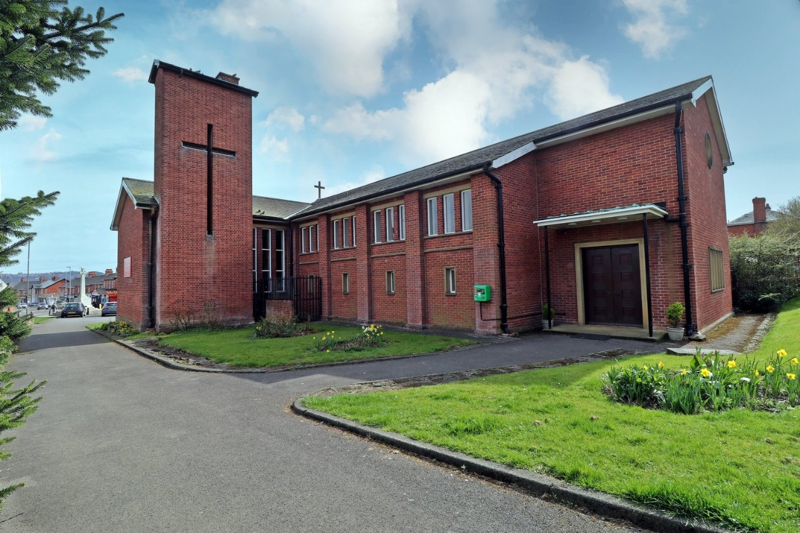

**Dunston**

**Parish Profile**

**Overview**

**Who we are - Mission statement**

We strive to be outward looking, welcoming and inclusive as we reach out to the Community we serve and build on links with schools and young people.

**Introduction**

Situated in the Centre of the large busy village of Dunston, Tyne and Wear is the beautiful modern Parish Church of St. Nicholas with Christ Church. The Church built in 1965 sits within its own grounds, replacing the original Churches of St. Nicholas on this site and at the opposite end of the village, Christ Church. Within the Church grounds, a modern and active Church Hall is situated which is in great weekly demand by various Community groups and Church members. Also, within the grounds lies the modern detached 4 bedroomed vicarage.

Dunston, a village of more than 10,000 residents, is now mainly a residential suburb to both nearby towns of Gateshead and Newcastle with good transport links to both towns and surrounding areas through trains, buses and the A1. In its past, areas of Dunston adjacent to the River Tyne contained a wide range of Industry.

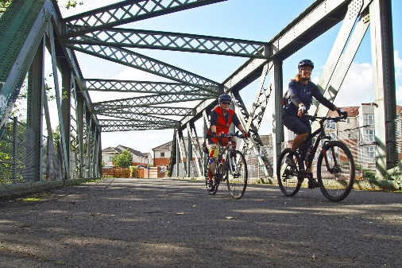

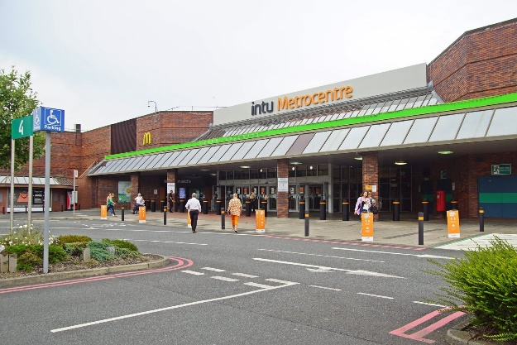Most of the heavy industry has now gone and the land has been reclaimed for small industry, ever expanding housing estates and the very large and popular Metro Centre shopping area.

The Church has for many years had a strong link with the community, care homes and the two primary and one secondary schools, all of which have a ‘good’ Ofsted rating. We also have good relationships with local councilors and the MP.

Within the strong and active PCC of 9 members, we have 1 Licensed Lay Minister, a practicing Funeral Minister and an active school Governor. Congregations have seen a reduction in numbers since the Pandemic. Sunday morning average attendance is currently 25 communicants with about 34 active members. The Wednesday morning service sees about 12 communicants. Festival services see larger congregations.

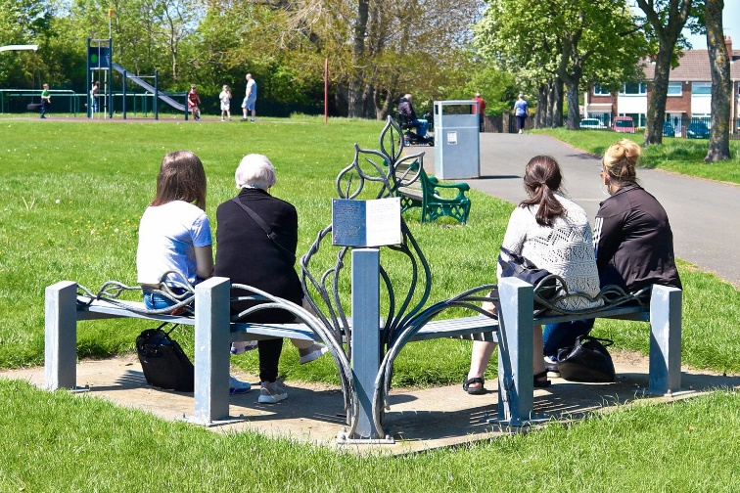A good size and well-maintained park is in the very centre of the village along with a modern swimming pool and other amenities including Library, Health Centre, Dentist, shops and a Community Centre used for sports and other events.

Within the boundaries lies a large green belt area with exciting views over the Tyne valley.

**Finance within the Church**

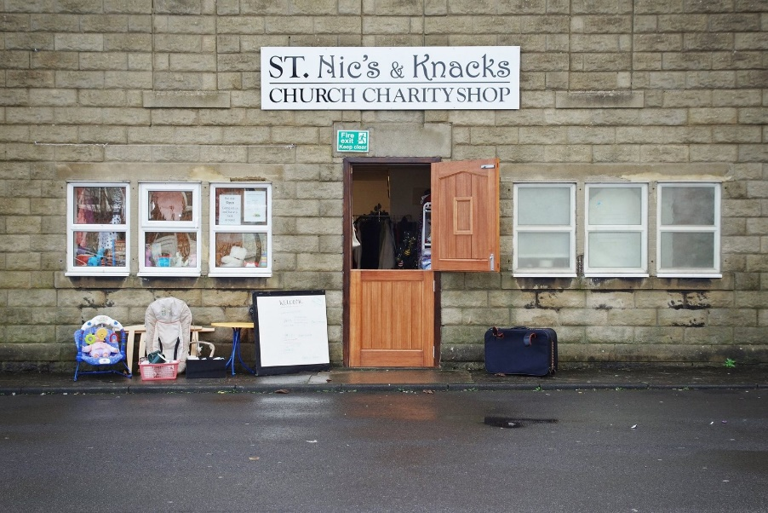

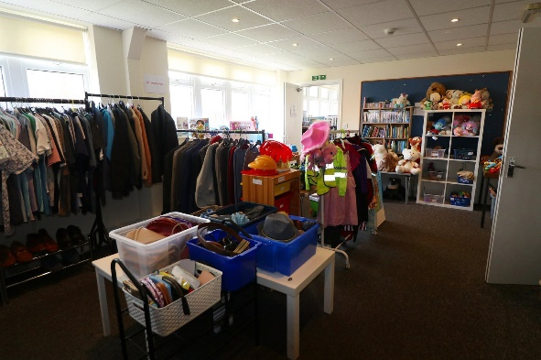

The Church finances are relatively healthy with a normal reserve covering about 6 - 9 months expenditure. Within a section of the Church Hall, our members set up a charity shop which is run totally by volunteers and is the only one in the area to offer the range of items that we do. It serves sections of the community well with proceeds from the shop going directly into Church funds. In 2024 this amounted to £26,000.

The Church prides itself as always paying the Parish Share in full. A stewardship giving scheme has been in place for many years. Like most Churches however in recent times reduction in numbers has impacted on the Church finances. Fortunately, this has been offset somewhat by the income from the Charity shop and Church Hall.

The finances are controlled by an experienced treasurer who is supported by the PCC, some of whom have business experience.

**Church Buildings**

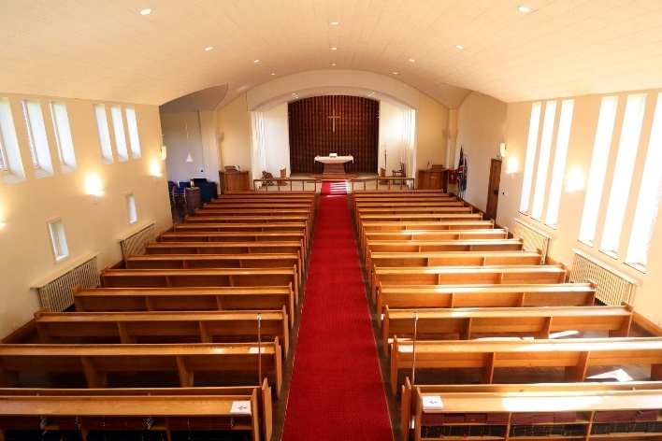**The Church**

The Church is a beautiful modern red brick building with a slate roof. It was built in 1965 on the site of a Church constructed in 1928.

The Church has a carpeted central aisle, and seating consists of oak pews on either side with a capacity for approx. 250 people. There are windows down both sides of the Church. To the front of the Church stands a thick sandstone main Altar on top of a brick plinth. Above the altar is suspended a large wooden cross.

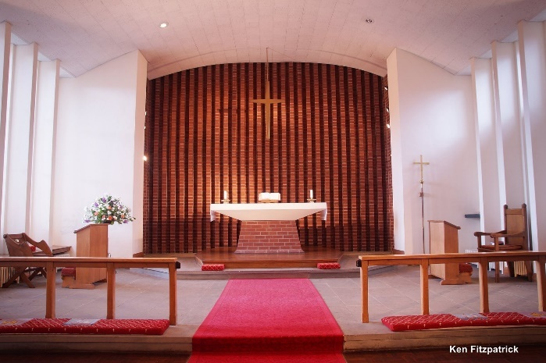

Either side at the front of the Church are a modern oak pulpit and lectern. A lady chapel is set off to the left in front of the Church. The main sanctuary is separated from the rest of the Church by a rigid oak communion rail. The ceiling of the Church is covered in acoustic ceiling tiles. This gives the Church excellent acoustics properties. There is easy wheelchair access to the entrance and main body of the Church.

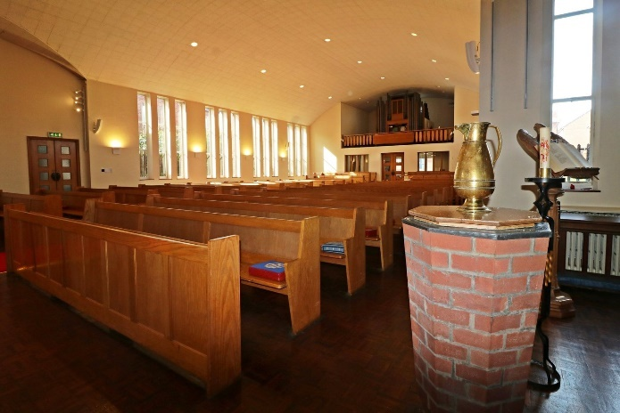The Church has recently been refitted with a low energy LED lighting system at a cost of £29,000.

The Church building also contains a choir vestry and Vicars parish office which is fully furnished.

All the Church buildings are in good state of repair. The Church is cleaned regularly by a Rota of congregation members. The last Quinquennial Inspection was carried out in 2022 and as a result all actions A & B are complete. All certifications associated with health and safety are up to date.

Heating of the Church comes from an oil boiler which was modified to use low emission fuel and is situated beneath the Church building

**Church Hall**

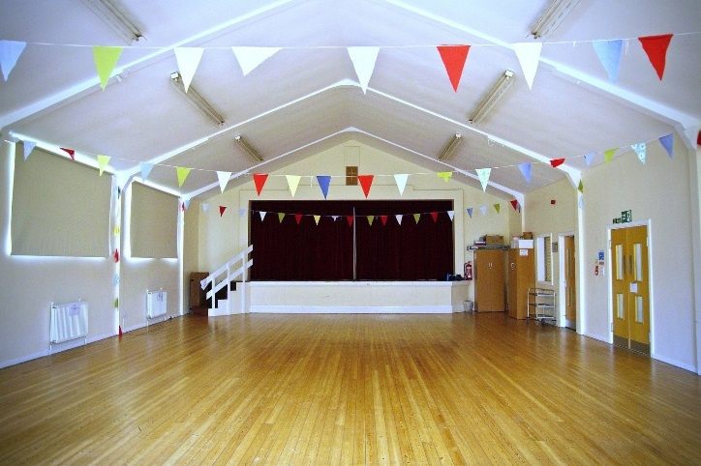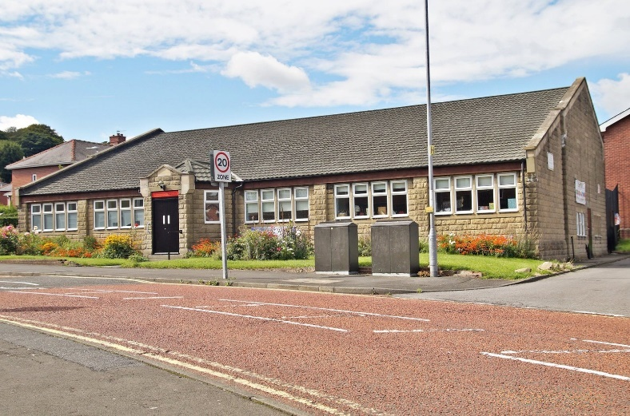Next to, but separate from the Church, is the Church Hall. This is a stone-built building with a modern slate roof. There is a large entrance area which gives access to the larger main upper hall with a modern kitchen and toilets.

The lower hall and stage have been used in recent times as a charity shop serving sections of the local community and contributing to the Church finances. The hall is used by many groups in the community as well as Church functions. The hall is cleaned weekly by a paid cleaner. Heating is supplied via a gas boiler stored externally to the hall.

**Church Grounds**

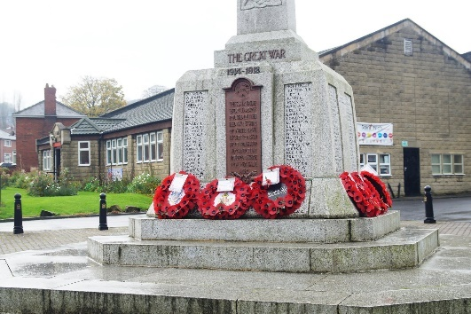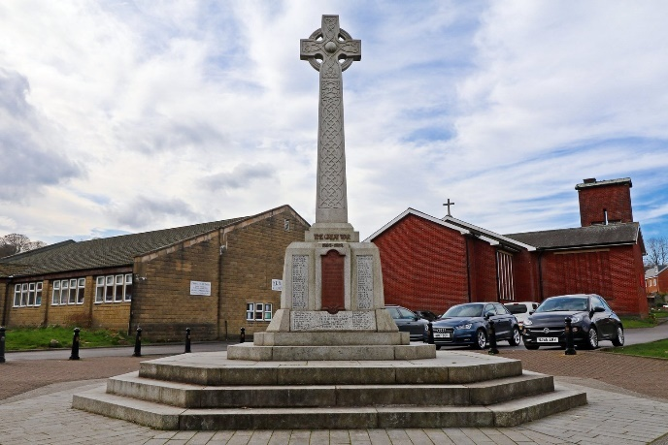The Church is surrounded by lawns and flower beds. Within the grounds is an enclosed garden which is used as a memorial garden. Access to this garden is through the Church or car park. There is a car park between the Church and hall which has a tarmac surface and is in excellent condition. Between one end of the car park and the main road is the war memorial. This is in the shape of a Celtic cross and is surrounded by paving. The memorial was renovated and rededicated in 2009. On Remembrance Sunday the Cenotaph continues to be a place of Remembrance for the whole community to come together.

**The Vicarage**

The vicarage stands within its own grounds and is connected to the Church via a corridor from the vicarage study. It is a lovely detached modern brick building, well maintained and in good decorative condition. There is a large driveway at the front of the building and a large private garden at the rear. Attached to the house is a garage. The building comprises two reception rooms, a study, a small cloakroom and a kitchen with a utility room, four bedrooms and a bathroom.

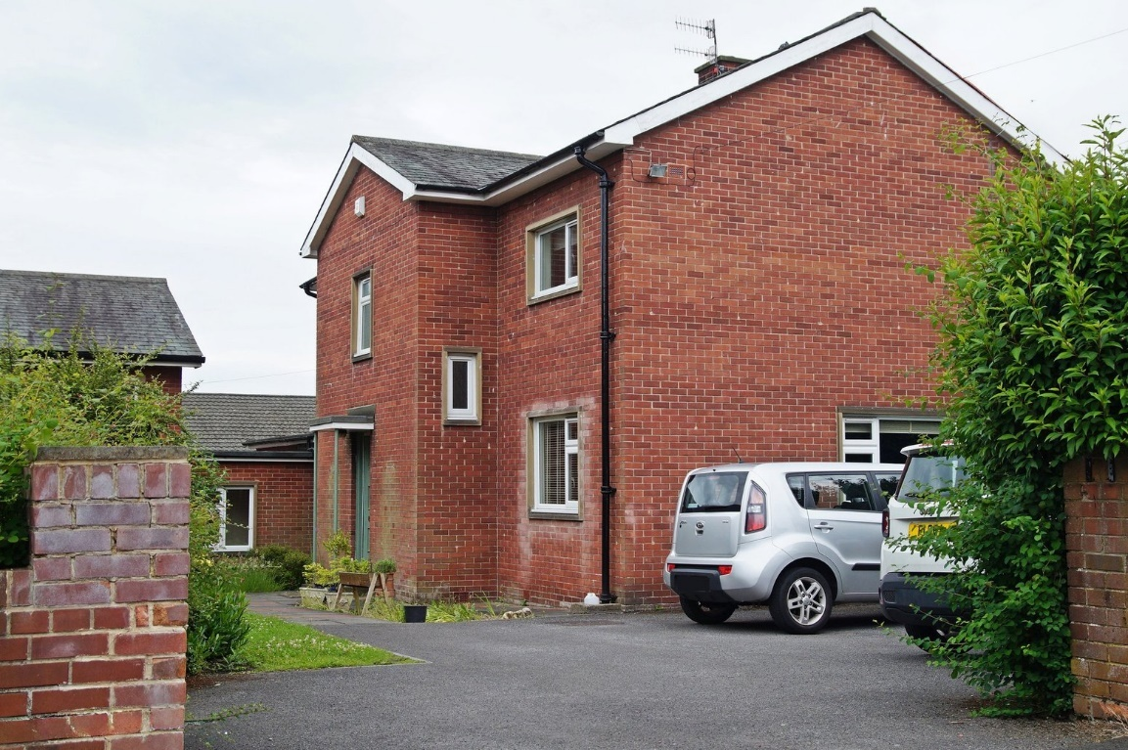

**Worship within the Church**

SUNDAY: 10.00am Holy Communion celebrated from Common Worship and sermon. Lay ministers of the Eucharist assist with administering Communion. For those not able to come to the altar rail, Communion can be administered to them in their seats.

Most baptisms are held on Sunday after our Holy Communion Service though of course, people are welcome to have their child(ren) baptised during the Eucharist too.

WEDNESDAY: 10.00am Said Holy Communion in church with Lay Ministers of the Eucharist to serve and assist with the chalice. Coffee is also available in the church hall after the service.

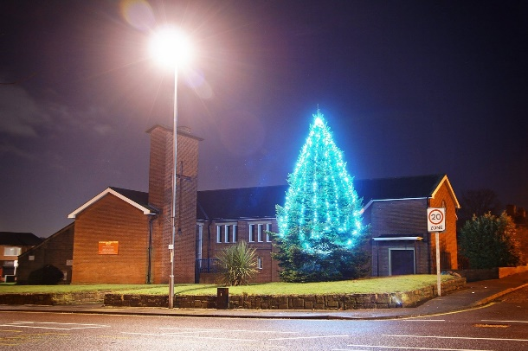SPECIAL SERVICES IN THE CHURCH’S YEAR Community Advent/Christmas Carol Service Christingle & Midnight Mass with Carols Ash Wednesday Mothering Sunday Palm Sunday Holy Week passion narratives, Maundy Thursday with Altar of Repose, Good Friday – Easter Liturgy Easter Day Ascension Day St Nicholas’s Patronal Festival Harvest Festival Remembrance Service and All Souls.

**Occasional Offices we held in 2023**

**Baptisms 30**

**Weddings 1**

**Funerals 27**

**What is our tradition of Worship?**

Our services are traditional Common Worship theme. Clergy are normally robed. We do have orders of service for the Church seasons and stand-alone services, however, we are open to new forms of worship too.

**Church Music**

The music within our worship is of traditional Anglican style using the Old and the New Hymn book.

The Church is fortunate to have a well maintained two manual Harrison organ, which is over one hundred years old, played by a long-standing professional organist. The music performed is enhanced by the excellent acoustic properties of the building.

There is also a new electric piano and modern sound system which allows the playing of music on CDs.

**We are looking for in a new incumbent.**

We are seeking to appoint someone with a healthy and demonstrable discipline of prayer and who exhibits an attractive and inspiring holiness and who will help us grow in our prayerfulness. As we grow in our mission, we need someone who is forward thinking with good leadership skills, one who would be able to lead, guide and develop our parish in current and new mission initiatives. We are seeking someone who will encourage us in all we do now and will take us into realms we have not yet reached. They will be enlivened by the Church of England tradition and want to see it flourish in our community, through a readiness to engage with our local community, build on the links we have with local schools, support and grow lay ministry, work alongside PCC and congregation and be a good listener and communicator with people from all backgrounds. A sense of humour may be called upon at times!

**We believe the following characteristics are important:**

* Embrace the whole community by being highly visible, approachable, and accessible.
* Be comfortable working with all the Organisations including children and the youth in the Parish to enable us to ‘grow younger’.
* Build and promote a working relationship with the schools and other clergy in the Deanery.
* Be a good communicator and manager of people who will empower us to develop further and deepen our faith, whilst demonstrating team player strengths.
* Be committed to worship with a Eucharistic and sacramental focus whilst encouraging a range of worship styles.
* Welcome, encourage and facilitate the involvement and development of all aspects of lay ministry.
* Embrace the whole community, supporting our open policy for baptisms, marriage, and funerals.
* Maximise the opportunity in opening our church hall to the community for non-religious events.

**In turn, we offer**

* A caring and supportive Church family.
* A warm welcome.
* A Church with an outstanding community tradition.
* Church members who are looking forward to working with you.
* An active role working with our three village schools celebrating services with them in Church during Christian festivals, supporting school assemblies and leading worship in local care homes.
* A team to assist in all acts of Worship and all aspects of Parish life, eg Licensed Lay Minister who is also authorised to take funerals.
* Licensed local parish and Deanery Funeral Minister.
* Two experienced Church Wardens.
* A fully operational and enthusiastic PCC, currently led by a lay PCC Chair and a Treasurer.
* A Parish Safeguarding Officer, a worship committee that designs and leads church services.
* A home communion team reaching out to the housebound and vulnerable within our community.

We look forward to welcoming you to share this exciting journey of faith and service as we seek to grow God’s mission together here in Dunston.