



**MICROGRANTS** for Energising Growth

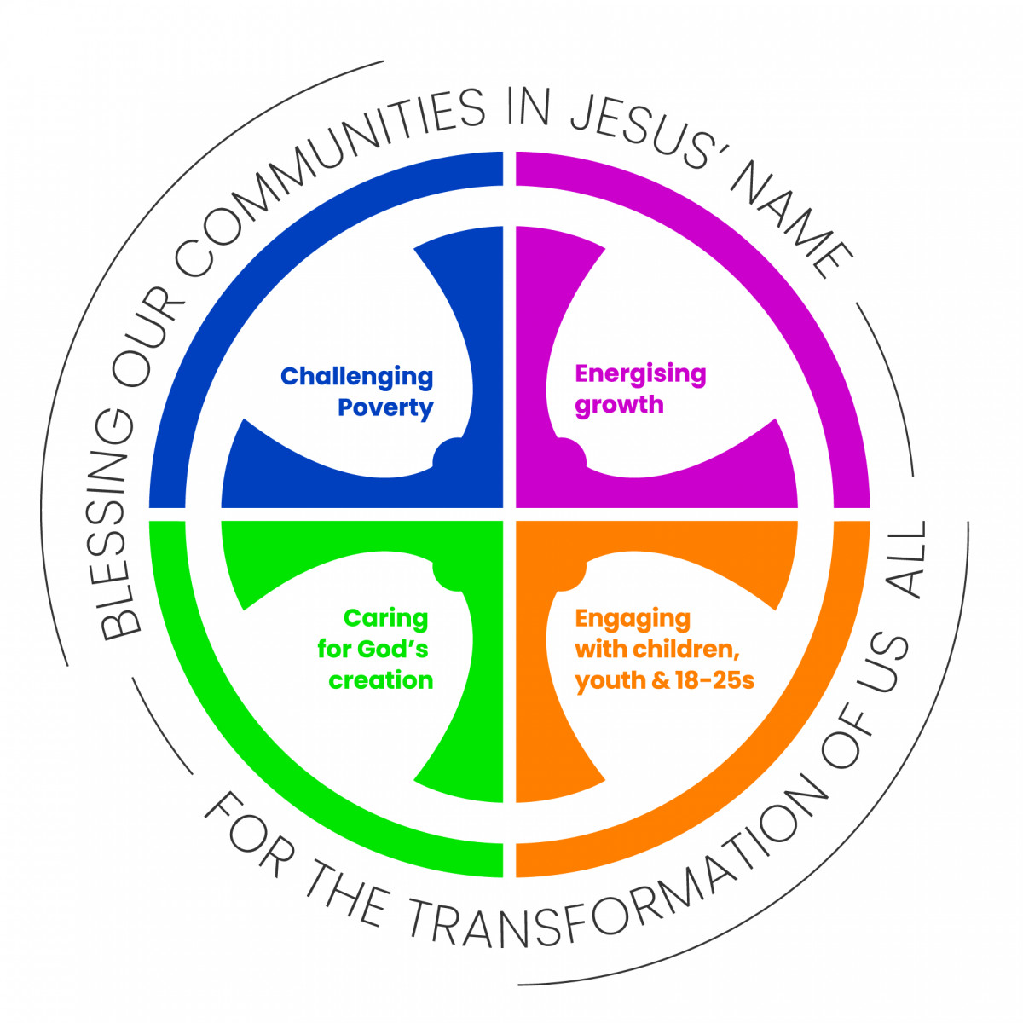

through Mission and Evangelism

**APPLICATION FORM**

**Energising Growth**

We will pray, support one another, plan and work together in order to foster growth in all our contexts, in order to:

1. **Grow in reach and influence** - working for the transformation of our communities through the transformation of our churches
2. **Grow in depth** – strengthening discipleship, being transformed by the renewing of our minds and choosing to reflect and serve Jesus by using our gifts to join in with his mission in every part of life
3. **Grow in breadth** – growth in the number of people identifying as Christian and fully participating in the life and mission of a local church family

|  |  |
| --- | --- |
| **Name of Parish, Benefice or Team** | |
| **Name of Incumbent or Churchwarden, if there is no incumbent** | |
| Deanery | Archdeaconry |

|  |
| --- |
| **Applicant / Contact Details**  **NAME:**  ___________________________________________________________  **EMAIL:**  ___________________________________________________________  **Preferred phone number:** __________________________________________ |

**PCC SUPPORT** See**Microgrant Guideline 6**

A condition for being awarded a microgrant is that your PCC have approved

the initiative and are resourcing it financially in some way. Please confirm:

|  |  |
| --- | --- |
| **The PCC of the above parish/ benefice/team have**  **agreed to this initiative going ahead** | **YES / NO** |
| **The PCC of the above parish/ benefice/team have given**  **financial support to the value of** | £ |

**Microgrant Guideline 4** says that **your initiative should fit into the wider mission**

**strategy** of your church / benefice and where possible within the Deanery and/or

**The 5 Marks of Mission**

The mission of the Church is the mission of Christ

1. To proclaim the Good News of the Kingdom
2. To teach, baptise and nurture new believers
3. To respond to human need by loving service
4. To transform the unjust structures of society
5. To strive to safeguard the integrity of creation

Diocesan Mission Strategy. *Please note that Microgrants* ***are not dependent on***

***saying ‘yes’*** *–* your response just gives us a clearer picture of what’s happening

where you are. Please tell us:

|  |  |
| --- | --- |
| **Does your PCC have a Mission Strategy?** | **YES / NO** |
| **If so, does this initiative fit into that overall plan?** | **YES / NO** |
| **Do you know what your Deanery Mission Plan says?** | **YES / NO** |

**Which of the Diocesan Priorities does your initiative meet?**

|  |  |
| --- | --- |
| **Energising Growth** | **YES / NO** |
| **Challenging Poverty** | **YES / NO** |
| **Engaging with Children and Young People** | **YES / NO** |
| **Caring for God’s Creation** | **YES / NO** |

**MICROGRANTS** for Energising Growth through Mission and Evangelism



**APPLICATION FORM**

**YOUR MISSION INITIATIVE** Is this a new initiative? **YES / NO**

Please give a short description of your new mission initiative. See **Microgrant Guideline 1**

If it has a specific name, please say what it is

|  |
| --- |
| **Name of Initiative**  _____________________________________________________________________ |

|  |
| --- |
| **Microgrant Guideline 2 explains the kind of evangelistic activity we are looking for**  **Say how this initiative will be evangelistic: in other words, in what ways do you expect the work will help your church to grow?** |

|  |
| --- |
| **What are the long-term hopes, aspirations and plans for this work?** See **Microgrant Guideline 3** |

|  |
| --- |
| **What will happen to your initiative if no mission grant is forthcoming?** |

**MICROGRANTS** for Energising Growth through Mission and Evangelism



**APPLICATION FORM**

**YOUR MISSION GRANT**

Each parish can apply once a year and access any amount up to £500.

Occasionally we may be able to give more, up to a limit of £1,000

Please say how much you are applying for: £ ____________

**How will the grant be spent?** See **Microgrant Guideline 5**

Please provide a simple breakdown of your projected costs below, adding rows as required

|  |  |  |
| --- | --- | --- |
| **Item** | **Detail** | **Cost** |
|  |  |  |
|  |  |  |
|  |  |  |
|  |  |  |
|  |  |  |
|  |  |  |
|  |  |  |
|  | **TOTAL** |  |

|  |
| --- |
| **How do you plan to assess the impact of the initiative over the short and long term?**  See **Microgrant Guideline 7** |

|  |
| --- |
| **DATE APPLICATION** **SUBMITTED** |

**MICROGRANTS** for Energising Growth through Mission and Evangelism



**APPLICATION FORM**

**SUCCESSFUL APPLICATIONS**

For audit purposes Microgrants are paid automatically by BACS transfer into PCC bank accounts. Please complete the account details below to help us complete the necessary transaction, should your application be successful. We aim to transfer the funds within 21 days of a grant being made.

|  |  |
| --- | --- |
| **Bank Name**  **Address** |  |
| **Account Name** |  |
| **Account Number** |  |
| **Sort Code** |  |

|  |
| --- |
| **SEND YOUR COMPLETED APPLICATION FORM TO**  [lizzie.helmsley@durham.anglican.org](mailto:lizzie.helmsley@durham.anglican.org)  Subject: **For the Attention of the Microgrants Administrator** |

**UNSUCCESSFUL APPLICATIONS**

If your application is not successful, please don’t give up!

It may be that with a few tweaks, or with a re-written application, you will be awarded the funds you need for your missional initiative. For advice and guidance, contact

**Ruth Young, Discipleship and Evangelism Enabler**

[**ruth.young@durham.anglican.org**](mailto:ruth.young@durham.anglican.org) **Tel: 07918 122875**





**FOR OFFICE USE ONLY:**

|  |  |  |
| --- | --- | --- |
| **PARISH / BENEFICE:** | | |
| Date of Application | Amount Requested | Granted YES / NO |
| Date of Grant Decision | Date of Reply to Applicant | Amount Granted |
| **NOTES** | | |