

**MICROGRANTS** for Energising Growth

through Mission and Evangelism

**Energising Growth** is one of our four Diocesan Strategic Priorities.

To support this the Diocese provides seed-funding for mission initiatives in Parishes and Benefices working to grow

* **in reach and influence** in their communities, through transforming their churches and congregations to be mission-shaped
* **in depth of discipleship**, by personal transformation through the renewing of our minds and hearts to be Christ-centred
* **in breadth**, by growing the number of people who are being transformed by their relationship with God, practising Everyday Faith, sharing in the life and worship of God’s family in their local church, and are becoming ‘Jesus-shaped’

We call these seed-funds **MICROGRANTS** for Energising Growth

Mostly the grants are made to help you get started on a new mission project. Each parish can apply once a year and access any amount up to £500, possibly more, though the limit is £1,000. There are some criteria guidelines to help you make your application. Check them out below, and when you’re ready, it’s easy to apply: just contact Cuthbert House for a form (details below) or look online. The form is easy to fill in, but if you have any questions about the form or about whether you qualify, just ask.

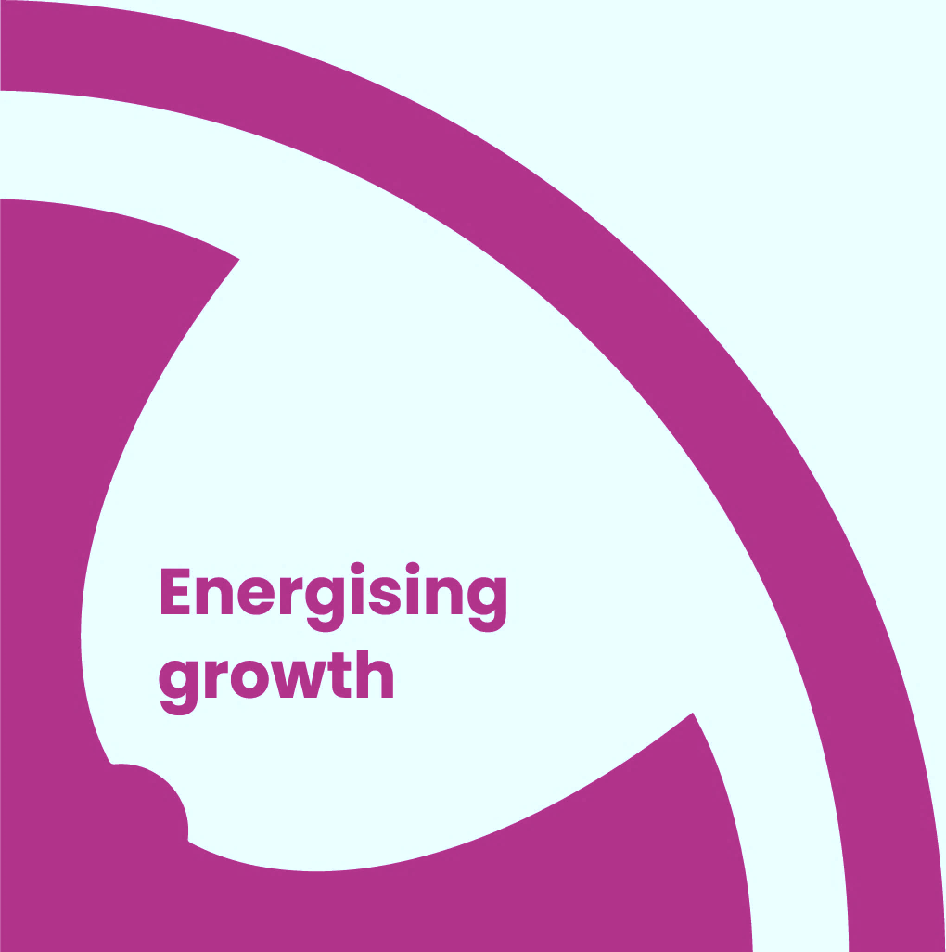

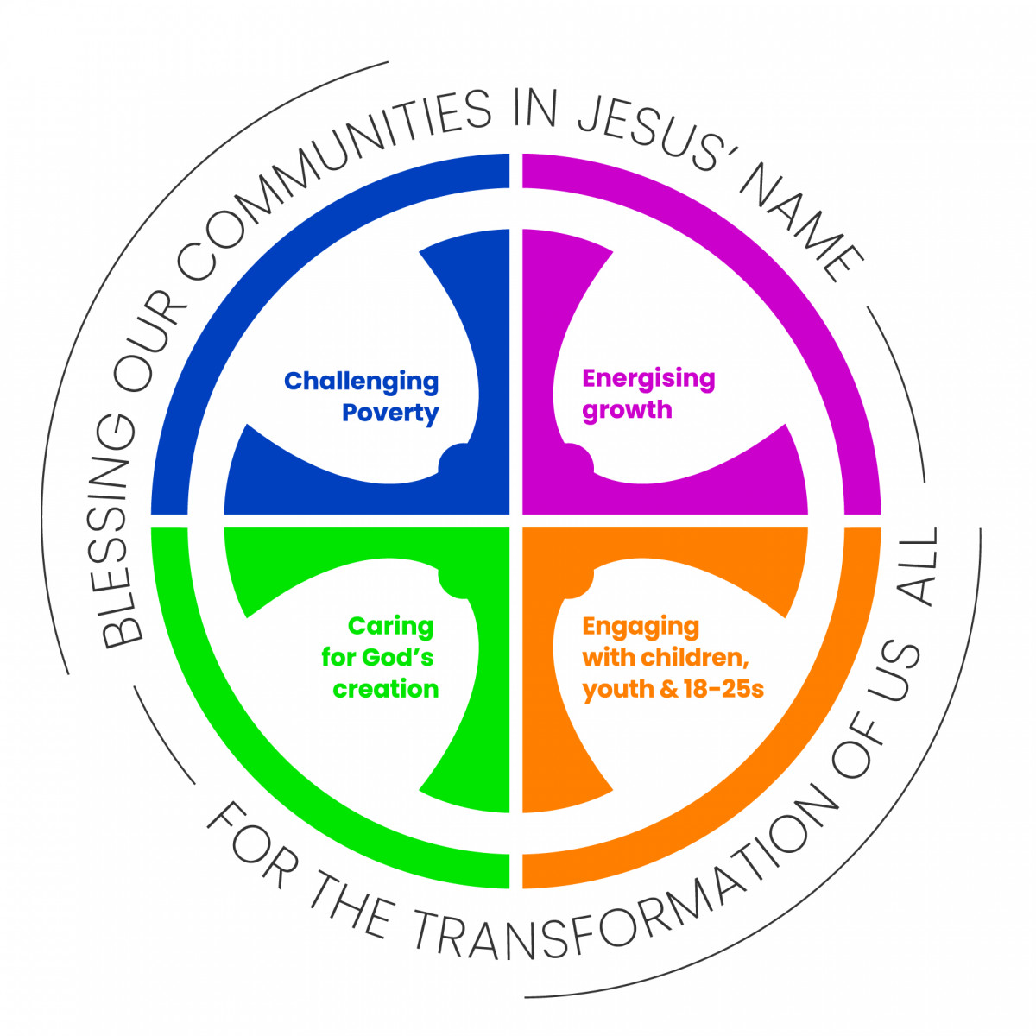

**Energising Growth**

We will pray, support one another, plan and work together in order to foster growth in all our contexts, in order to:

1. **Grow in reach and influence** - working for the transformation of our communities through the transformation of our churches
2. **Grow in depth** – strengthening discipleship, being transformed by the renewing of our minds and choosing to reflect and serve Jesus by using our gifts to join in with his mission in every part of life
3. **Grow in breadth** – growth in the number of people identifying as Christian and fully participating in the life and mission of a local church family

**MICROGRANTS CRITERIA and GUIDELINES**

To qualify for a Microgrant you must be able to show that

1. **This is a new mission initiative**: we don’t give follow-on grants for existing projects or activities
2. **There is a clear evangelistic element** to the project: think about how you will build good relationships which open the way for you to introduce people to living Christian faith – how will you make disciples?
3. **You have clear aspirations, intentions and plans for the long-term:** we may consider funding ‘launch’ events but we want to be sure that there will be *ongoing engagement in mission and evangelism* with the people you feel called to work with
4. **Your initiative fits into the wider mission strategy** of the church / benefice / deanery or diocese
5. **The project has been properly costed:** *please provide a breakdown of your projected costs.* It helps you and us to have clarity about how much you need and how it will be spent
6. **Your church / PCC support the initiative and are resourcing it** financially in some way
7. **You have plans in place to evaluate the project**, not just in terms of numbers but in the impact it might have. We can advise you on this if necessary, as we may come back to you for news stories

To see the Diocesan Strategic Priorities, go to <https://durhamdiocese.org/about-us/diocesan-priorities/>

If your initiative doesn’t fit with one of these, ***still apply***. For example, you may want to work with older people or adults with special needs: *as long as there is an evangelistic / missional element, your application will be considered.*

**Just be COURAGEOUS and CREATIVE!**



For more information or to ask for a Microgrant Application Form, contact our Administrator, Lizzie Hemsley, at the Diocesan office: [lizzie.hemsley@durham.anglican.org](mailto:lizzie.hemsley@durham.anglican.org)