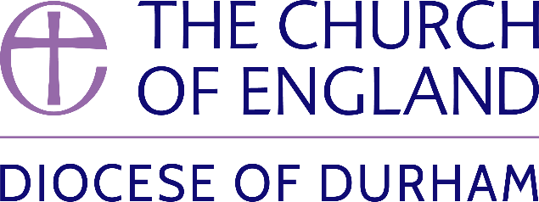 | DIOCESE OF DURHAM  Movement of Clergy: January – February 2024
Name | Current Post | New Post | Effective Date
(1) MOVEMENT TO OR WITHIN THE DIOCESE:
Hudson, The Revd Sr Dawn Margaret | Curate, Hillside (Lobley Hill and Marley Hill) | To be ordained Priest by the Bishop of Jarrow | 07.01.24
Miller, The Revd Mark George | Vicar, Stockton Parish Church | To be also Honorary Non-Residentiary Canon of Durham Cathedral | 14.01.24
Tarling, The Revd Matthew Paul | Vicar, Spennymoor and Whitworth | To be also Honorary Non-Residentiary Canon of Durham Cathedral | 14.01.24
Brown, The Revd Richard Alexander Hamilton | Priest in Charge, Marsh Farm (Holy Cross), (St Albans) | SSM Public Preacher, Diocese of Durham | 07.02.24
(2) MOVEMENT FROM THE DIOCESE:
Gunn, The Revd Edward James | SSM Curate, Auckland St Helen | Shrine Priest of the Shrine of Our Lady of Walsingham (Norwich) | 15.01.24
Atkinson, The Revd David | Vicar, Dunston St Nicholas with Christ Church | Priest in Charge, Benefices of Seghill and Delavel (Newcastle) | 11.02.24
(3) RESIGNATIONS:
(4) RETIREMENTS:
Hendry, The Revd Rosemary | SSM Assistant Priest, Greenside St John |  | 01.01.24
Butler, The Rt Revd Paul Roger | Bishop of Durham |  | 29.02.24

Published 9 January 2024| Bishop of Durham’s Office

